Κάνε τις αλλαγές στην επικεφαλίδα
ATHENS CANDIDACY: taking each participant more personally
Άφησε ένα κενό
Experience, Willingness, Professionalism, Hospitality
Άφησε 2 κενά

Dossier of Candidacy for BIOCERAMICS-27 in Athens 2015

This is the electronic presentation of the Dossier of Candidacy of the University of Ioannina, Greece, to host and organize the 27th International Conference of the International Society of Ceramics in medicine (ISCM), BIOCERAMICS-27, in Athens in the autumn of 2015.

It has been prepared by the Coordinator and Chairman of the Candidacy Associate Professor Simeon Agathopoulos, Professor of Ceramics Technology in the Department of Materials Science and Engineering in the University of Ioannina, Greece, and TRIAENA Congress Organizing Agent S.A., that will be the organizing agent.

The candidacy is endorsed by many eminent Greek scientists, who have high interest and scientific affinity to Bioceramics, and the Greek Scientific Societies of Biomechanics, Ceramics, and Biomaterials, and enjoys the support of Greek Ministers and Political Officers.

The file of candidacy has considered every single issue, even the ultimate detail, with regard to the organization, presented them in the Dossier of Candidacy (αυτό το προσθέτεις) with the highest possible clearance, transparency, and detail.
Άφησε μια κενή γραμμή
Our motto for organizing this Conference is: “taking each participant more personally”.

The candidacy in brief:

Prof. S. Agathopoulos is one of the 4 Greek Professors on Ceramics in Greece (the other 2 professors are included in the Organizing Committee; the forth one does not work on bioceramics at all). He was awarded with the first Ph.D. on Bioceramics in Greece in 1994. His work has been presented in more than 150 publications and more than 250 presentations in Scientific Congresses (a large number of them in Bioceramics Conferences), which hashave received more than 1500 citations. He is active in any type of bioceramics, from the stage of production to clinical application. He is currently President of the Greek (Hellenic) Society of Biomechanics and member of the Greek Societies of Ceramics and Biomaterials.

The Organizing Committee proposed gathers all the Greek Professors with relation to Bioceramics. They represent all the Greek Universities, Laboratories on Ceramics and the relevant (to Bioceramics) Scientific Societies. The proposed Organizing Committee represents the wider possible Scientific Consortium with all the Greek scientist and Institutions that truly and systematically focus their research at developing Ceramics and Bioceramics.

TRIAENA S.A. is the oldest and currently the biggest agency for organizing Conferences in Greece. Moreover, the scheme of the coordinator (Prof. S. Agathopoulos) and the Organizing Agency (TRIAENA S.A.) has organized the 6th International Conference on High Temperature Capillarity (HTC-2009) held in Athens, in 4-6 May, 2009, with a great success, in terms of (i) excellent organization, (ii) high scientific level of the Conference, and (iii) perfect social events.

The complete Dossier of Candidacy is presented in details in the links of this website.

Yours sincerely,

Simeon Agathopoulos, Ph.D., Associate Professor
sagat@cc.uoi.gr, www.agathopoulos.org

Αυτό από κάτω είναι καινούργιο και πρόσθεσέ το κάτω από το κείμενο (αν γίνεται όπως το έχω, σε κουτάκι). Τις εικόνες των logos στις στέλνω ξεχωριστά (για να τις διαχειριστείς εσύ όπως σε βολεύει καλύτερα).

Greek Candidacy for Bioceramics-27, Athens 2015
Chairing and Coordination of Candidacy and Conference: S. Agathopoulos, Ph.D.
Associate Professor of Ceramics Technology, University of Ioannina, Greece
Organizer
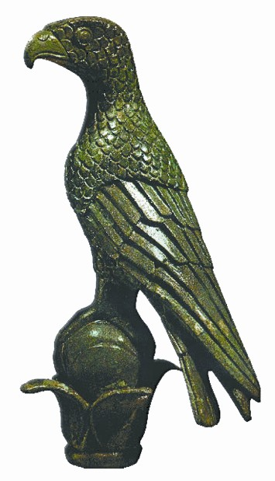 | University of Ioannina (UoI)
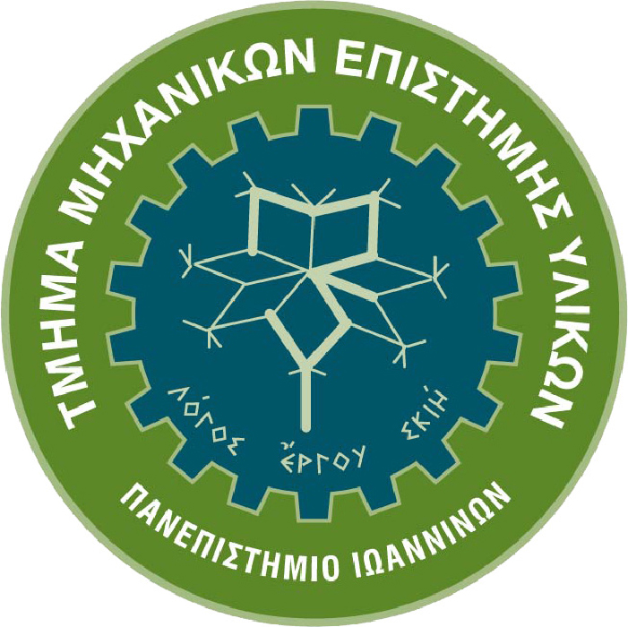 | Dept. Materials Science and Engineering (DMSE)
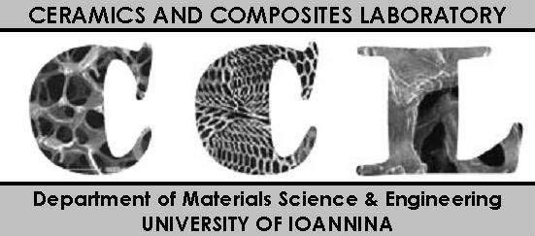 | Laboratory of Ceramics and Composites (CCL)
The Conference is endorsed by the Greek (Hellenic) Scientific Societies
(represented in the Organizing Committee)
 | Greek (Hellenic) Society of Biomechanics  President: Assoc.Prof. Simeon Agathopoulos
 | Greek (Hellenic) Society of Ceramics  President: Assoc.Prof. Athena Tsetsekou
 | Greek (Hellenic) Society of Biomaterials  President: Assoc.Prof. Triantafillos Papadopoulos

