Scientific Consortium of the Candidacy

Chairperson of candidacy
Simeon Agathopoulos
www.agathopoulos.org

- Associate Professor of Ceramics Technology
Laboratory of Ceramic Materials and Composites (CCL)
Department of Materials Science & Engineering (DMSE), University of Ioannina (UoI)

- President of the Greek (Hellenic) Society of Biomechanics

Press here to see more information about S. Agathopoulos

Organizer

- University of Ioannina (UoI), Laboratory of Ceramics and Composites (CCL), Dept. Materials Science and Engineering (DMSE)

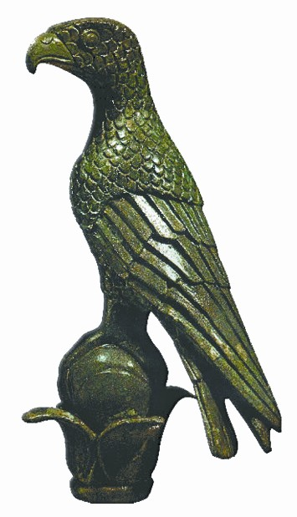 | 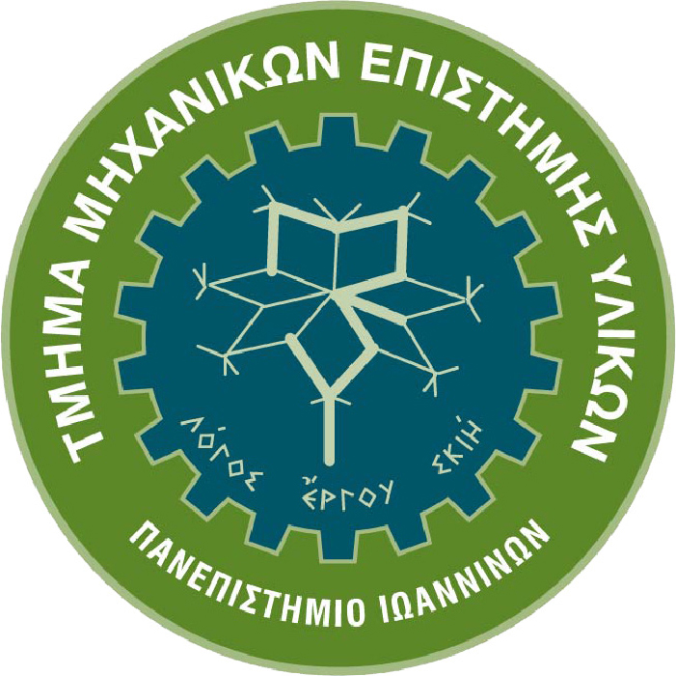 | 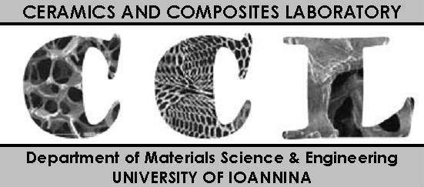
University of Ioannina (UoI) | Dept. Materials Science and Engineering (DMSE) | Laboratory of Ceramics and Composites (CCL)
Press here to see the more information about CCL, DMSE and UoI.

The Conference is endorsed by the Greek (Hellenic) Scientific Societies
(represented in the Organizing Committee)

 |  | 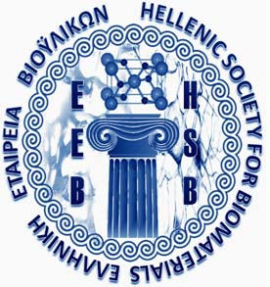
Greek (Hellenic)  Society of Biomechanics  President: Assoc.Prof. S.Agathopoulos | Greek (Hellenic)  Society of Ceramics  President: Assoc.Prof. A.Tsetsekou | Greek (Hellenic)  Society of Biomaterials  President: Assoc.Prof. T.Papadopoulos

Organizing Committee

The Organizing Committee, presented in section I, gathers all the experts (professors, scientific societies and research laboratories) in (a) Ceramics and (b) Biomaterials in Greece, as shown in the analysis presented in section II.

I. Suggested List of the Members of the Organizing Committee (OC)

President of the Organizing Committee

Simeon Agathopoulos
Associate Professor
Laboratory of Ceramics & Composites (CCL), Dept. Materials Science & Engineering (DMSE), University of Ioannina (UoI)
- President of the Greek Society of Biomechanics

Press here to see more information about him

Vice Presidents
(alphabetically)

Michael Karakassidis  Professor  University of Ioannina  - Director of the Laboratory of Ceramics and Composites, University of Ioannina  - President of the Dept. Materials Science and Engineering, University of Ioannina  M.K. is Professor of Ceramics and Glasses. His is among the best (worldwide) scientist in Glasses and in analyzing their structure with spectroscopic techniques. He has developed novel phosphate and borate bioactive glasses and glass-ceramics. | Triantafillos Papadopoulos  Associate Professor  University of Athens, Dental School, Laboratory of Biomaterials  - President of the Greek Society of Biomaterials  T.P. can be considered as the “father” of biomaterials in Greece; thus he established the Greek Society of Biomaterials 10 years ago and he recently achieved to undertake the organization of the ESB-2017 Conference in Greece. His research involves characterization of dental bio-ceramics (HA, glasses, coatings) and their performance as dental implants. |  | Athena Tsetsekou  Associate Professor  National Technical University of Athens, Dept. of Metallurgy Engineers  - President of the Greek Society of Ceramics  A.T. is Professor of Ceramics. She is among the very few Greek Professors with long, systematic and great experience on ceramics, from the most traditional ones to the most advances ones, both their synthesis and characterization. Recently, she has developed nano-bioceramics with novel biomemetic methods of her own inspiration.
Members
(alphabetically)

Dia Andreouli, Ph.D.  - Director of the Greek Ceramic and Refractory Research Centre (CERECO)  CERECO is the only Ceramic Institution in Greece and is semi-private but also belongs to the Ministry of Development. It participates in almost all projects and research on Ceramics carried out in Greece, including bioceramics. D.A. has long experience on ceramics technology as a researcher and now as the director of the Greek Ceramic Centre. |  | George Angelopoulos, Professor  University of Patras, Dept. Chemical Engineering  - Director of the Laboratory of Metallurgy and Ceramics  - Vice Rector of the University of Patras  G.A. has long experience on metallurgy, ceramics and composites. Both traditional ceramics and advanced ones have been at the focus of his research. He has a vast experience both in industry as well as in the laboratory. His studies deal with development of novel materials with high added value.
Andreas Beris, Professor  University of Ioannina, Medical School  - Director of the Laboratory of Orthopaedics  A.B. is expert on orthopaedic microsurgery. He has a big research team that is active and famous both in applied clinics (University Hospital) and research. Among his scientific collaborations, he is collaborating with materials engineers to study novel approaches of tissue engineering by using novel scaffolds, of ceramics and composites of ceramics and polymers, which can act and function both as scaffolds and drug delivery systems. |  | Nikos Bouropoulos, Associate Professor  University of Patras, Dept. Materials Science  The research of N.B. deals with calcium phosphate ceramics of biological origin, such as hydroxyapatite, TCP, OCP, monetite etc., which are spontaneously developed in several biological systems, such as in the heart, in urine system etc. He has developed novel bioceramics. His studies mainly focus on the factors which affect the formation of these Ca-phosphate compounds in the body and the mechanisms of their formation as well as the ways that they can be dissolved.
Maria Chadjinikolaidou, Associate Professor  University of Crete, Biomaterials Lab, Dept. Mater. Sci.  The research of M.C. focuses directly and exclusively to biomaterials. She is developing novel structures that provide suitable nano-conformations for good attachment of cells, mainly bone cells (e.g. osteoblasts) which can be used as promising scaffolds for bone tissue engineering. Beyond synthesis, she focuses on their characterization (in vitro tests) and the mechanism of cell-materials interactions. |  | Vangelis Christoforou, Professor  National Technical Univ. of Athens, Dept. Metallurgy Eng.  V.C. is expert on metal and ceramic materials and mainly their electromagnetic properties. Among his research interests, he has remarkable achievements on developing and studying ceramic materials suitable for hyperthermia treatments for cancer therapy. His work on this type of ceramics makes him to be invited to participate as a member of the OC in this Bioceramics conference.
Despina Deligianni, Associate Professor  University of Patras, Dept. Mechanical Eng.  - Director of the Lab of Bioengineering  D.D. is now director of the Laboratory of Bioengineering, which was established and directed for about 3 decades by Prof. Yannis Missirlis, who was recently (2013) retired. She is continuing the good tradition of this famous laboratory on bioengineering research. Her studies focus at characterization in vitro of new biomaterials, not only with classical biological tests but also she studies the performance of cells (in contact with biomaterials) under realistic conditions of mechanical stress. Recently, her research focuses systematically at the performance of C-nano-tubes as potential biomaterials. |  | Dimitris Fotiadis, Professor  University of Ioannina, Dept. Mater.Sci.Eng.  - Director of the Lab of Bioengineering and Bioinformatics  D.F.’s research is applied to almost all directions of clinical applications of biomaterials, including biosensors and devices, like artificial hands, legs, eyes etc. The results of his research team, that counts many post-doctoral and PhD researchers, support many activities of medical doctors from all fields, such surgeons etc., materials scientists and electrical engineers who work at signaling. He has a big number of papers, citations as well as many patents, many of them awarded by many institutions and governmental organizations. His research attracts a large number of projects and funds.
Dimitris Gournis, Professor  University of Ioannina, CCL, Dept. Mater.Sci.Eng.  The research of D.G. deals with nano-ceramics. He has published numerous papers in the best Journals of Materials and his work has attracted a large number of citations. His studies focus on nano-tubes, fullerenes, graphene as well as clay minerals, synthesis and characterization. These materials aim at several applications, including bioceramics mainly for drug delivery systems, whereby the functionalized nano-ceramics surface can immobilize drugs which can be released (after implantation) to the body. |  | Theofillos Kolettis, Professor  University of Ioannina, Medical School  T.K. is among the very few experts in Greece for arrhythmia diseases. He has developed a systematic research at myocardium therapies after heart infarction (heart attack), which is often followed by arrhythmia. In the last 7 years, he has developed collaboration with materials scientists to develop novel biomaterials that can provide support to the myocardium tissue after infraction and delivery of cells and growth hormones with the aid of polymer/nano-ceramic composite scaffolds.
Petros Koutsoukos, Professor  University of Patras, Dept. Chemical Engineering  - Director of Laboratory of Chemistry  P.K. can be considered as the older (and thus the most experienced) professor in Greece on the chemistry of calcium phosphates. His research focuses on the factors which affect the formation of Ca-phosphates, namely pH, super-saturation of meta-stable conditions in a solution, influence of other factors, such as sugars, peptides, hormones etc. In his papers, he provides thorough interpretation of his experimental results in the light of thermodynamics and the mechanism of nucleation and crystal growth. Biologically derived apatites in any system in the body attract the focus of his research. |  | Nikos Mihaillidis, Associate Professor  Aristotle University of Thessaloniki, Dept. Mechanical Eng.  N.M. is a faculty member and works in the Laboratory of Metallurgy. His expertise is metallic and ceramics foams. With regards to the latter ones, his interest aims at bioceramics. Recently, he has developed collaborations to study in vitro (with osteoblasts) their performance as bone substitutes. Except developing and characterizing experimentally novel foams, he is also specialized at theoretical studies with finite element analysis. With regards to bioceramics, these studies have focused to bone spine studies, and particularly the analysis of the stresses developed in these bones as well as in bone substitutes such as metallic, ceramics or composite implants.
Apostolos Papalois, Professor  - Director of the Research Laboratory of the pharmaceutical company ELPEN, Greece  The Research Laboratory of ELPEN, directed by A.P., provides to all Greek scientists (with no charge) chirurgical tables to carry out operations with laboratory animals, provided that the research is novel and approved by him. Thus, A.P., beyond a great scientist, is doubtlessly a big supporter of biomaterials and medical science and research in Greece and thus he must be a member of this OC. |  | Panos Patsalas, Associate Professor  Aristotle University of Thessaloniki, Dept. of Physics  P.P. is expert on nano-films of ceramics. His research deals with all type of films, including bioceramics. He is expert both at synthesis and characterization. Thus, he is expert in all the most modern techniques needed in the technology of thin layered ceramics, such as deposition with sputtering, Laser ablation etc., as well as XPS, ESCA, XRD etc. His participation in the OC aims to cover the area of coatings as one of the best, now, Greek scientist in this field.
Kostas Sikalidis, Professor  Aristotle University of Thessaloniki, Dept. Chemical Eng.  - Director of the Laboratory of Ceramics  K.S. has a long experience on ceramics, since he is the director of the Ceramics Laboratory in the Aristotle University of Thessaloniki. The activities of his Laboratory aim at all fields of ceramics technology. In the field of bioceramics, he has developed novel biomaterials based on HA and zeolites, which can be used as drug delivery systems in cancer therapies. |  | Tiverios Vaimakis, Professor  University of Ioannina, Dept. of Chemistry  - Director of the Laboratory of Industrial Chemistry  T.V. has a long experience on synthesis and characterization of ceramics. Photocatalysis (with titania) and bioceramics of HA and calcium phosphates have mainly attracted his scientific activities the recent years. Beyond the classical characterization techniques, he is also expert at thermal analysis, which is of great importance in HA-bioceramics, bioglasses and composite materials.

II. Analysis of the completeness of the proposing Organizing Committee (OC):

(a) The OC has representatives from all the Greek Universities:

University of Athens and National Technical University of Athens | T.Papadopoulos, A.Tsetsekou, V.Christoforou
Aristotle University of Thessaloniki | N.Mihaillidis, K.Sikalidis, P.Patalas
University of Patras | D.Deligianni, G.Angelopoulos, P.Koutsoukos, N.Bouropoulos
University of Ioannina | S.Agathopoulos, M.Karakassidis, D.Fotiadis, A.Beris, Th.Kolettis, D.Gournis, T.Vaimakis
University of Crete | M.Chadjinikolaidou

(b) The OC has representatives from all the Departments of Materials Science

University of Ioannina | S.Agathopoulos, M.Karakassidis, D.Gournis, D.Fotiadis
University of Patras | N.Bouropoulos
University of Crete | M.Chadjinikolaidou

(c) The OC has all the Professors of Ceramics and Glasses in Greece whose research focuses on bioceramics

- S.Agathopoulos
- M.Karakassides
- A.Tsetsekou

Note: There are 4 Professors in Greece on Ceramics, Glasses and Ceramics Technology but the research of the forth one, Prof. Christos Argyrousis, aims at electroceramics.

(d) The OC has representatives from all the Laboratories whose research deals with bioceramic materials

Laboratory of Ceramics and Composites, University of Ioannina | S.Agathopoulos, M.Karakasides, D.Gournis (T.Vaimakis, Chemistry Dept.)
Biomaterials Laboratory, University of Athens, Dental School | T.Papadopoulos
Laboratory of Metallurgy, National Technical University of Athens | A.Tsetsekou, V.Christoforou
Laboratory of Chemistry of Materials, University of Patras | P.Koutsoukos
Laboratory of Chemistry of Biomaterials, University of Patras | N.Bouropoulos

(e) The OC has representatives from all the Laboratories whose research systematically deals with ceramic materials:

Laboratory of Ceramics and Composites, University of Ioannina | S.Agathopoulos, M.Karakasides, D.Gournis
Laboratories in Metallurgy Department, NTUA | A.Tsetsekou, V.Christoforou
Laboratory of Ceramics, Univ. Thessaloniki | K.Sikalidis
Laboratory of Metallurgy, Aristotle University of Thessaloniki | N.Michailidis
Laboratory of Metallurgy and Ceramics, University of Patras | G.Angelopoulos
CERECO | D.Andreouli

(f) The OC has representatives from all the scientifically related Scientific Greek Societies:

Greek Society of Biomechanics | President Assoc. Prof. S. Agathopoulos
Greek Society of Ceramics | President Assoc. Prof. A. Tsetsekou
Greek Society of Biomaterials | President Assoc. Prof. T. Papadopoulos

(g) The OC has representatives from all the fields of Bioceramics:

Production, characterization (bulk, porous, coatings) | S.Agathopoulos, M.Karakassides, A.Tsetsekou, P.Patsalas, T.Vaimakis
Mechanical properties (spine bones) and porous (foams) ceramics | N.Michailidis
Chemical properties and biological bioceramics | P.Koutsoukos, N.Bouropoulos
Drug delivery systems and nano-ceramics (including functionalization) | D.Gournis
Magnetic materials (hyperthermia) | V.Christoforou
Biomechanics | D.Deligianni
Bioengineering-bioinformatics | D.Fotiadis
Orthopedics (clinical application and in vivo tests) | A.Beris
Dentistry (characterization and clinical performance) | T.Papadopoulos
Cardiology (in vivo tests, tissue engineering) | T.Kolettis
Biological (in vitro) testing and tissue engineering | M.Chatzinikolaidou
Application (industrial production and protocols of in vivo testing) | A.Papalois, D.Andreouli

