- CCL (Laboratory of Ceramics and Composite Materials)
- Department of Materials Science and Engineering
- University of Ioannina

CCL (Laboratory of Ceramics and Composite Materials)
http://www.materials.uoi.gr/ccl/

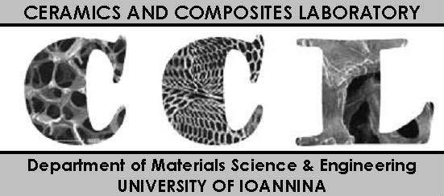

Associate Professor S. Agathopoulos is member of the Laboratory of Ceramics and Composite Materials (CCL).
He has the highest number of publications and citations on Ceramics and Biomaterials than any other Greek Professor.

CCL has 2 more faculty members:

- Professor Michael Karakasides, Director of the Lab, Chairman of the Department of Materials Science and Engineering. He is the best (in terms of publications and citations) Greek professor in Glasses (silicate, phosphate and borate glasses). He has also presented outstanding studies on nano-ceramics (mainly mesoporous materials and carbons).

- Prof. Dimitris Gournis. He is among the best (in terms of publications and citations) Greek Professors in nano-ceramics (production, functionalization including immobilization and drug delivery).

The research in CCL covers all types of ceramics, namely ceramics, glasses, glass-ceramics, and nano-ceramics.
Bioceramics is a main aim of the Laboratory (and not an occasional or peripheral target; this is underlined because many of the other Greek colleagues who also present papers occasionally on bioceramics do not often come from an original Ceramics Laboratory). In particular, with regards to the applications in biomedicine, apatites, glasses (silicates, borates, phosphates), glass-ceramics (lithium disilicates, micas), composites (with degradable polymers or ceramic-metal compostes), complex drug delivery systems and tissue engineering scaffolds are primary aims of the Laboratory.

CCL is the best laboratory in Greece on Ceramics (in terms of publications and citations):
The 3 faculty members have
about 350 publications, some of them in top Journals of Materials, and
more than 5000 citations.

Note: In Greece, although many people work on ceramics, officially there are just 4 Professors on Ceramics; the 2 of them, i.e. Prof. Agathopoulos and Prof. Karakassides, are in CCL.

CCL has offered many PhDs, Masters and Diploma Theses. Currently, more than 20 young students and researchers are working in CCL.

CCL has gathered many National and European projects (with a budget of more than 1 million Euros).

CCL has many contacts and collaborations with all the Greek Laboratories on materials, the Greek Scientific Societies and many prestigious Universities all over the world.

Department of Materials Science and Engineering
http://www.materials.uoi.gr



In Greece, there is only one Engineering Department on Materials Science (there are two more departments but merely on Materials Science but not Engineering, in the University of Patras and the University of Crete).

“Biomaterials” is a clear aim of the Department.

The field of Bioceramics is served by the staff of CCL.

The Department of Materials Science and Engineering was established in 1999 and it has now 24 faculty members. It is ranked at the top 5 University Departments in Greece, in terms of the quantity and quality of scientific production and excellence, and attracts funding from National and International projects. The Department produces annually about 110 publications in peer reviewed international scientific journals (conferences are not included), which receive about 2000 citations per year.

University of Ioannina
www.uoi.gr

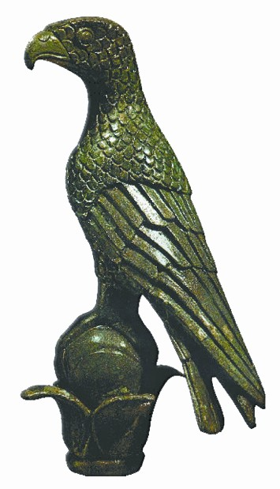

The University of Ioannina has many excellent eminent scientists, with high international reputation and remarkable CVs in the fields of Ceramics and Biomaterials (e.g. CCL) as well as Bioengineering and Biological Characterization and Orthopaedics, who will be activated if this candidacy will be approved and the Executive Committee qualify the University of Ioannina to be the Organizer of the Conference Bioceramics-27:

Dimitris Fotiadis, Professor (suggested as member of the Organizing Committee)
(Dept. of Materials Science and Engineering)
- Director of the Laboratory of Bioengineering and Bioinformatics
- Ex -director of Scientific and Technology Park of Ioannina and Epirus Prefecture
He is expert on Bioengineering and Bioinformatics. His CV exhibits remarkable scores in publications, patents, projects and novel projects (awarded with prizes of excellence).

Andreas Beris, Professor (suggested as member of the Organizing Committee)
(Clinics of Orthopaedics, Medical School)
- Director of the Clinics of Orthopedics of the University Hospital, specialized in microsurgery.
He is among the best surgeons on orthopaedic microsurgery. He also promotes novel research in orthopaedics in the framework of numerous PhDs carried out under his supervision in his Clinic (e.g. testing via in vivo implantation of novel biomaterials constructs in experimental animals).

Theodore Fotsis, Professor
(Medical School)
- Director of the Institute of Biological Studies of the Foundation of the Research and Technology of Greece (FORTH)
- Geek Representative of Research in the European Commission.
In his Institute, numerous big projects on biological studies, biomaterials, health treatments etc. are carried out.

Harry Stamatis, Professor
(Biology Department)
He is expert in characterization techniques of biological materials, biomaterials, drug-carriers and drug delivery systems etc.

Panagiotis Kouklis, Associate Professor
(Medical School)
He is expert on cell cultures, cells differentiation etc. on cultures and scaffolds.

Tiverios Vaimakis, Professor (suggested as member of the Organizing Committee)
(Department of Chemistry)
He is expert on the chemistry of calcium phosphate bioceramics.

Maria Louloudi, Professor
(Department of Chemistry)
She is expert in production (chemical) methods, such as sol-gel, co-precipitation etc., of special ceramics and glasses, including gels and nano-scaffolds, suitable for drug delivery systems, or hyperthermia applications.

Theofilos Kolettis, Professor (suggested as member of the Organizing Committee)
(Cardiology Clinic, Medical School)
He is expert at heart diseases (infarction, arrhythmia) and therapies via implantation of scaffolds with specific drug delivery features via polymer/nano-ceramics composites (testing via in vivo implantation in experimental animals).

