Social Events – Conference Tours – Excursions

The Organizers consider the Social Events as a high importance issue in a Conference because they assist forging further the contacts among the participants in a more leisure and relaxing way. Moreover, Greece and particularly Athens is a gifted place and a perfect blend of natural beauty, long history and Greek hospitality, and the participants of a scientific conference must taste all of them!

Included in the Registration Fees

Therefore, the Registration Fees include the participation in the following events (beyond the 2 lunch breaks and the 5 coffee breaks):

Welcome Dinner on Wednesday night (20:00-23:00) with sea food at a tavern at Piraeus (Tsakos),

Welcome Reception with Fine Cheese and Special Greek Wines on Thursday night (19:00-21:30) at the Hotel (along with the Poster session).

Moreover, for the accompanying persons, we shall organize tours to see the centre of the city, e.g. Constitution Square (Syntagma), the House of Parliament, the Memorial to the Unknown Soldier, the Presidential Palace, as well as tours for shopping in the Center of Athens or visits to the important Museums, e.g. Acropolis Museum, Archaeological Museum, Byzantine Museum etc.

Conference events and tours (not Included in the Registration Fees)

The following excursions and tours are not included in the registration fees. However, they are strongly recommended because we have pressed down their cost and we have planned them with a special care in order to present the best to the participants.

Pre-conference tour:
Cape Sounion on Wednesday afternoon
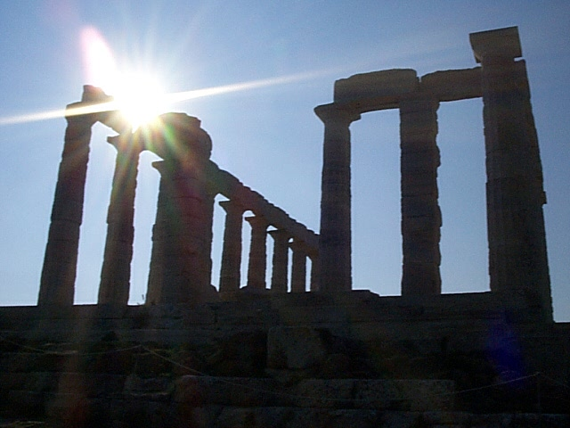
Drive along the coastal road, pass the wonderful beaches of Glyfada, Vouliagmeni and Varkiza to the most southern point of Attica, Cape Sounion, where the white marble pillars of the Temple of Poseidon stand. On the way you have a splendid view of the Saronic Gulf and the little islands offshore. After visiting the Temple of Poseidon, you have time to walk at leisure on the rocky promontory of Sounion.
Estimated cost: 20 Euros per person.

Banquet on Friday evening (20:30-23:00).
Cost: 50 Euros per person.

Conference tour:
“Greek Night” on Saturday (16:00-23:00)
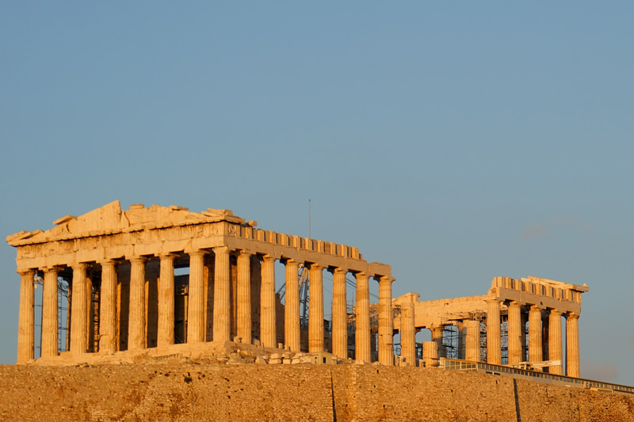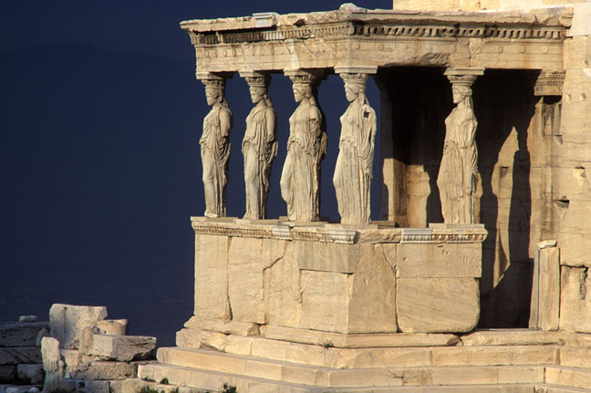

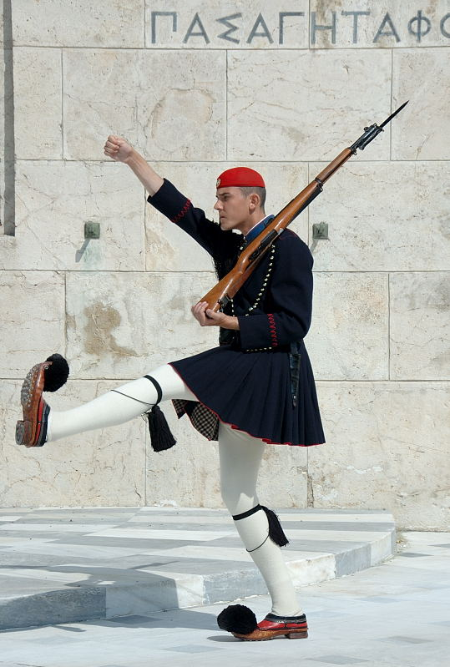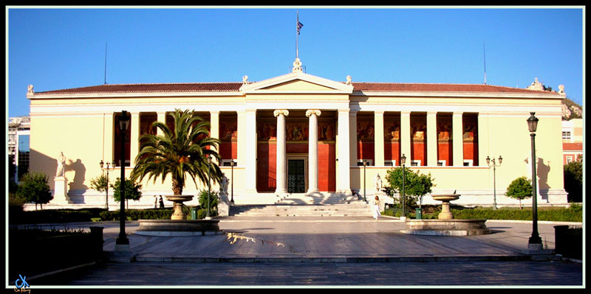

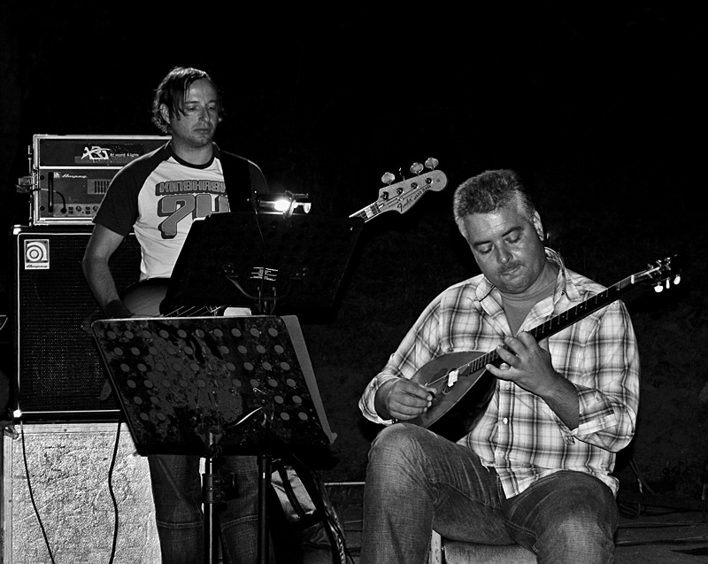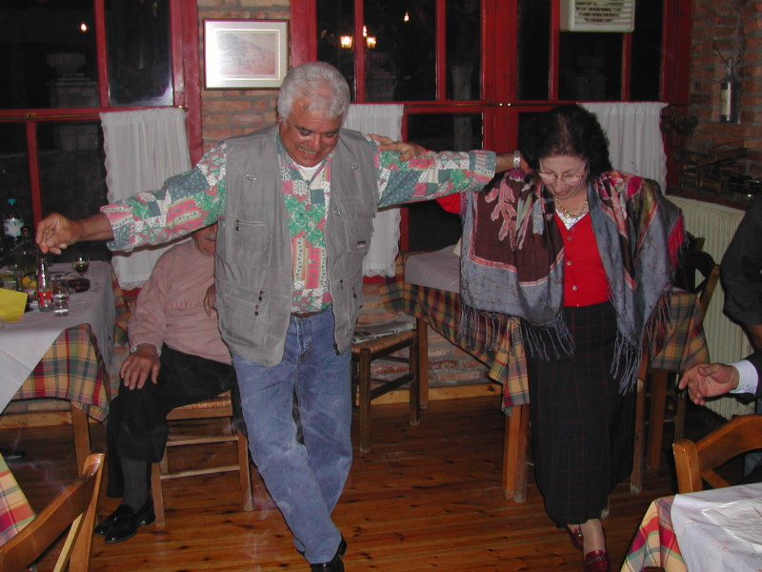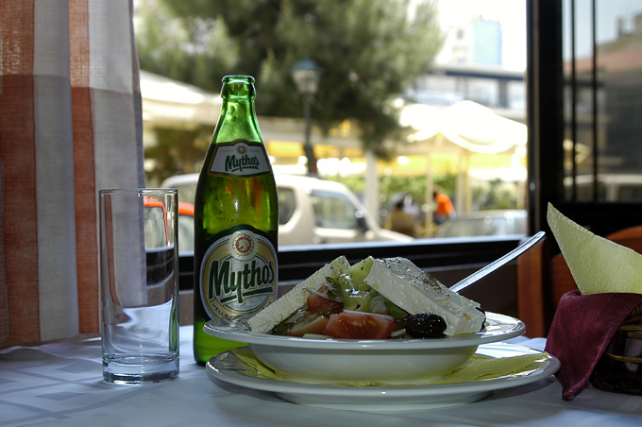
- Busses will pick up the participants from the Hotel and will offer a guided tour that will give the visitors the opportunity to observe the striking contracts that make Athens such a fascinating city (16:00-17:00)
- Climbing (! on foot) to Acropolis Hill (Propylea, the Temple of Athena Nike, Erehthion, the Parthenon) (17:00-17:45)
- Walk (on foot) along the Ancient Keramikos and Thission shrine (17:45-18:45)
- Walk (and shopping for souvenirs) along the narrow commercial street of the Old City (Thission, Monastiraki) (18:45-20:00)
- Greek Night (Greek dinner, music and dance) at a restaurant at Plaka (old city) (20:00-23:00)
- Return (on foot – 5-10 minutes) to the Hotel
This tour has been specially (and smartly) planned in order to allow the participants to join (and exit) the tour at any time and any spot (the Hotel is always nearby the route of the tour).
Estimated cost: 30 Euros per person.

Post conference tour:
Delphi one-day tour on Sunday (9:00-18:00)
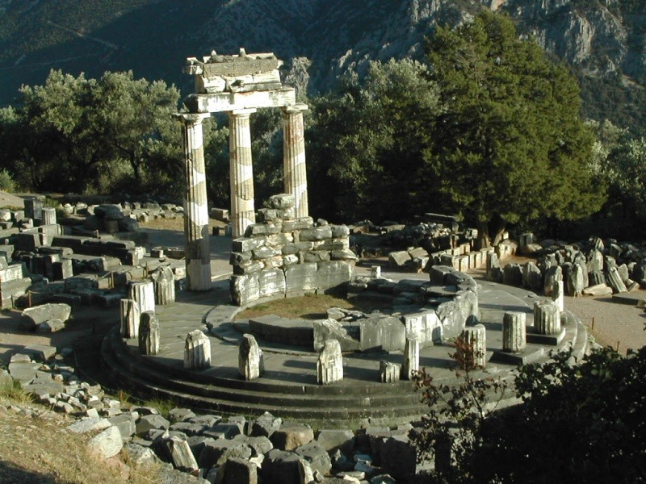
Delphi is the centre of the Ancient world, the Navel of the Earth, whose prestige extended far beyond the boundaries of the Hellenic world. On the slopes of Mount Parnassus, in a landscape of unparalleled beauty and majesty, lie the ruins of the Sanctuary of Apollo Pythios. We shall visit the Treasury of the Athenians, the Temple of Apollo and the Museum containing such masterpieces of ancient Greek sculpture as the bronze Charioteer and the famous athlete Aghias. Lunch will be offered at Arachova cosmolitan village.
Estimated cost: 50 Euros per person (including the lunch).

… and more excursions …

The organizers are also ready to provide the participants with the following tours and excursions, which can be scheduled according to their desires. Any destinations and more complex schedules are also available upon request. The cost of these excursions will be given to the participants upon request.

Argolis One-Day Tour
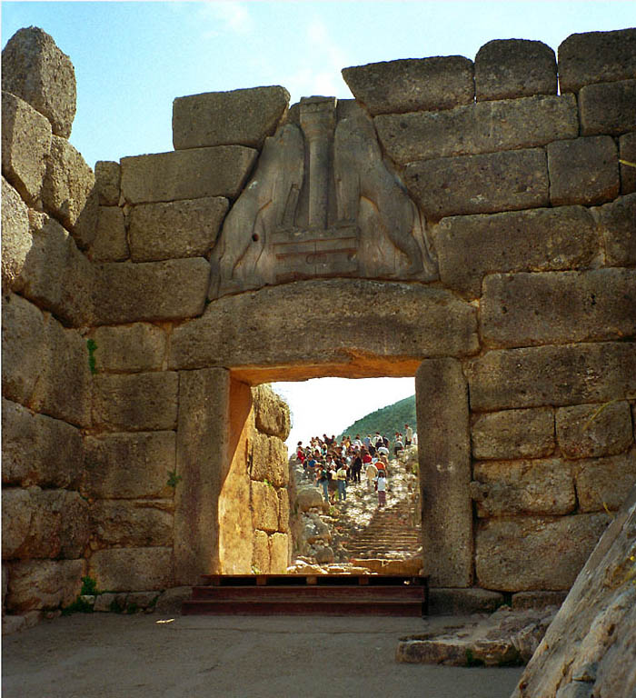 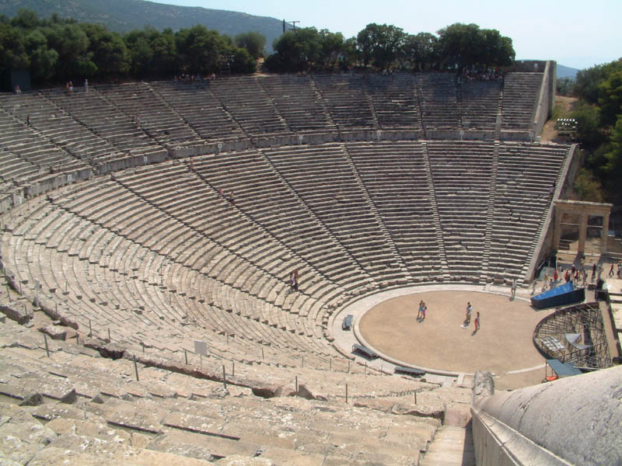
During this tour you will visit Mycenae, the Homeric city of Atrides, the ancient theatre of Epidaurus (4th century B.C.) and the picturesque town of Nafplion.

Full Day Cruise to the Saronic Islands
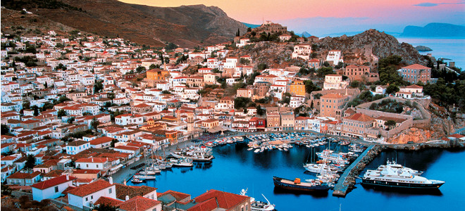
During this Cruise you will be able to visit three cosmopolitan and beautiful Saronic Islands, Poros, Hydra and Egina, enjoy swimming in the crystal clear waters and visit the famous temple of Afea Athina.

4 Days Classical Tour
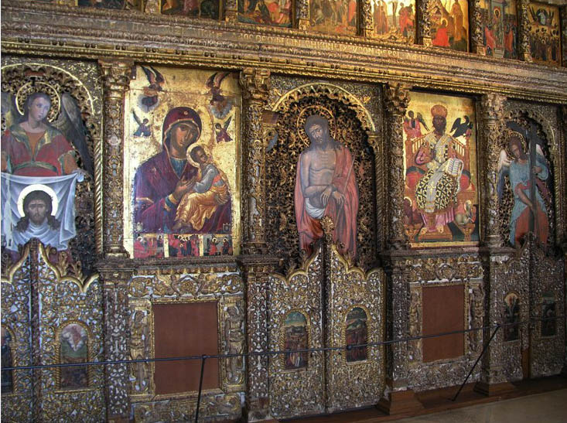 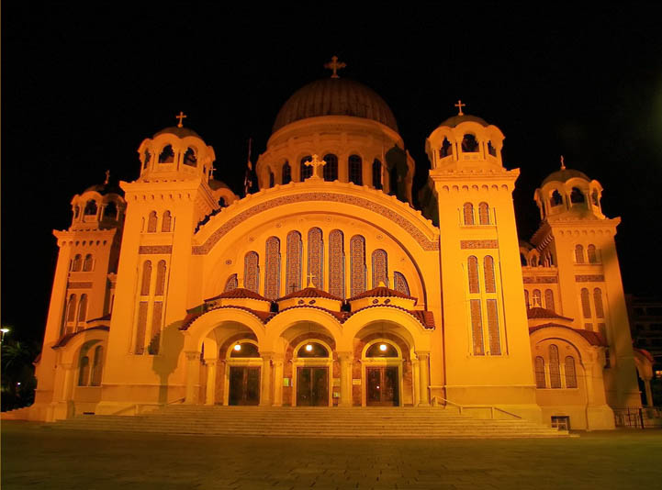
Prehistory, the Classical period, Roman domination, the Byzantine Empire, the Crusades, modern times: Greece through the centuries will unfold before you on this four-day tour.

Three-Four-Seven Day cruises
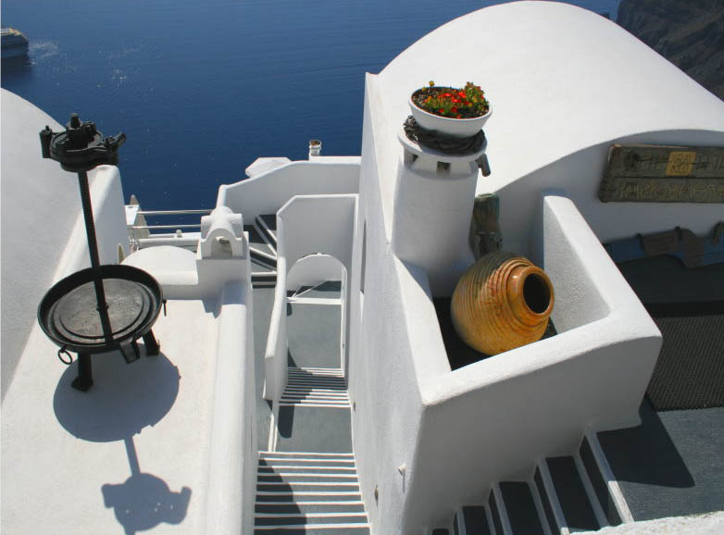 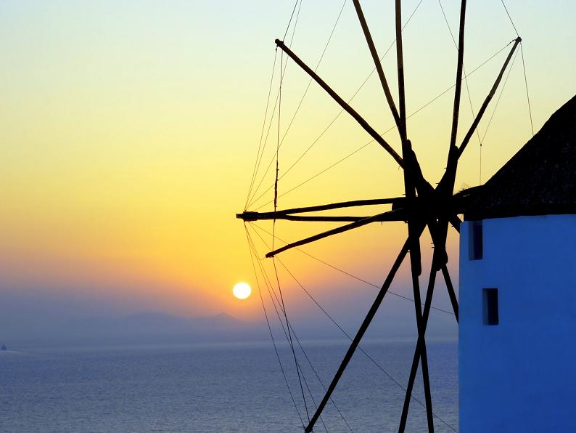 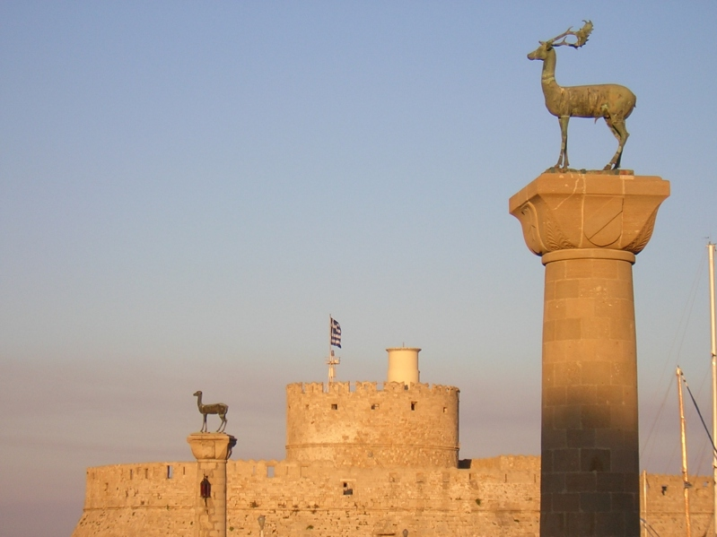
These cruises are perfect introduction to the Aegean. In just a couple of days you will cruise through the most beautiful waters in the world to the most enchanting destinations: Mykonos, Rhodes, Patmos, Santorini and Crete are all on the program.

